Abstract
Traffic congestion often prevents emergency vehicles, especially ambulances, from reaching hospitals on time, leading to critical delays in life-saving treatment. To address this issue, this project presents an AI-based smart ambulance detection and traffic signal control system that integrates computer vision, deep learning–based sound recognition, and IoT communication.
The proposed system uses a YOLO-based object detection model to identify ambulances from real-time camera feeds by analyzing vehicle shape and distinctive color patterns. To enhance reliability and reduce false detections, a CNN-based ambulance siren detection model processes live audio captured through a microphone. Mel-spectrogram features are extracted from the audio signals, and noise reduction techniques are applied to improve classification accuracy. An ambulance is confirmed only when both visual and acoustic detections are positive.
Once an ambulance is detected, the system automatically communicates with the Blynk IoT cloud platform to trigger a control signal, enabling traffic lights to switch to green and provide a clear path for the emergency vehicle. The system operates in real time, is cost-effective, and does not require specialized hardware beyond standard cameras and microphones.
Experimental results demonstrate that the dual-mode detection approach significantly improves accuracy and robustness compared to single-source methods. This solution offers a scalable and intelligent framework for smart city traffic management systems, with the potential to reduce emergency response times and improve public safety.

1. Introduction
Rapid urbanization and the increasing number of vehicles on roads have made traffic congestion a major challenge in modern cities. One of the most critical consequences of traffic congestion is the delay faced by emergency vehicles such as ambulances, fire engines, and police vehicles. In medical emergencies, even a delay of a few minutes can significantly impact patient survival rates. Traditional traffic signal systems operate on fixed timing mechanisms and are unable to dynamically respond to emergency situations, resulting in inefficient traffic management.
To overcome this limitation, intelligent traffic control systems using Artificial Intelligence (AI) and Internet of Things (IoT) technologies have gained increasing attention. Automated detection of ambulances and dynamic traffic signal control can help provide a clear and uninterrupted path for emergency vehicles, thereby reducing response times and improving public safety.
This project proposes an AI-based smart ambulance detection and traffic signal control system that combines computer vision and sound-based deep learning techniques to achieve high detection accuracy. The system employs a YOLO (You Only Look Once) object detection model to identify ambulances from real-time video feeds captured using a standard webcam. Visual detection is enhanced by analyzing vehicle structure and color patterns commonly associated with ambulances.
In addition to visual recognition, the system integrates a Convolutional Neural Network (CNN) for detecting ambulance sirens from real-time audio input. Mel-spectrogram features are extracted from the audio signals after applying noise reduction, enabling robust classification even in noisy urban environments. The dual-modal approach ensures that an ambulance is confirmed only when both visual and audio evidence is present, significantly reducing false detections.
Once an ambulance is detected, the system communicates with the Blynk IoT cloud platform to transmit control signals to traffic management devices. This enables automatic switching of traffic signals to green, allowing the ambulance to pass safely through intersections. The proposed system is cost-effective, scalable, and suitable for real-world smart city applications, as it relies on commonly available sensors and cloud-based IoT infrastructure.
Overall, this system demonstrates how the integration of AI, deep learning, and IoT can provide an efficient and intelligent solution for emergency traffic management, contributing to faster emergency response and enhanced urban safety.

Objectives
The main objective of this project is to design and develop an AI-based intelligent ambulance detection and traffic signal control system that can reduce emergency response time in congested urban environments. The specific objectives of the project are as follows:
- To detect ambulances in real time using computer vision techniques from live camera feeds.
- To develop a deep learning–based sound recognition system for detecting ambulance sirens using audio signals.
- To implement a dual-mode detection mechanism that confirms ambulance presence only when both visual and acoustic detections are positive, thereby reducing false alarms.
- To extract and process Mel-spectrogram features from audio data for accurate siren classification.
- To integrate the detection system with an IoT platform (Blynk Cloud) for real-time data transmission and traffic signal control.
- To automate traffic signal switching to provide a green corridor for ambulances during emergency situations.
- To design a cost-effective and scalable system using commonly available hardware such as webcams and microphones.
- To improve overall traffic management efficiency and public safety in smart city environments.

Scope of the Project
The scope of this project defines the boundaries and applicability of the proposed system. The system is designed with the following scope:
- The project focuses on ambulance detection at traffic intersections using real-time video and audio data.
- The visual detection module is limited to identifying ambulance-like vehicles based on shape and color patterns using a YOLO-based model.
- The audio detection module is restricted to classifying emergency vehicle sirens, such as ambulance sounds, from environmental noise.
- The system is implemented as a real-time prototype and does not control physical traffic signals directly, but communicates control commands through an IoT cloud platform.
- The solution is suitable for smart city applications, including traffic monitoring and emergency vehicle prioritization.
- The current implementation supports a single camera and microphone setup at an intersection.
- The system is designed for urban road conditions and may require further tuning for rural or highway environments.
- Future enhancements may include support for multiple intersections, additional emergency vehicles, GPS integration, and real-time signal optimization.

System Requirements:

Hardware
- Computer/Laptop (i5 or above recommended)
- Minimum 8 GB RAM
- Webcam (720p or higher)
- Microphone (built-in or external)
- Internet connection
- ESP32/ESP8266 (optional for traffic control)

Software
- Windows / Linux OS
- Python 3.8+
- OpenCV
- TensorFlow / Keras
- NumPy
- Librosa
- SoundDevice
- NoiseReduce
- Scikit-learn
- Requests library

Models & Platforms
- YOLO object detection model
- CNN-based ambulance siren detection model
- Blynk IoT Cloud platform

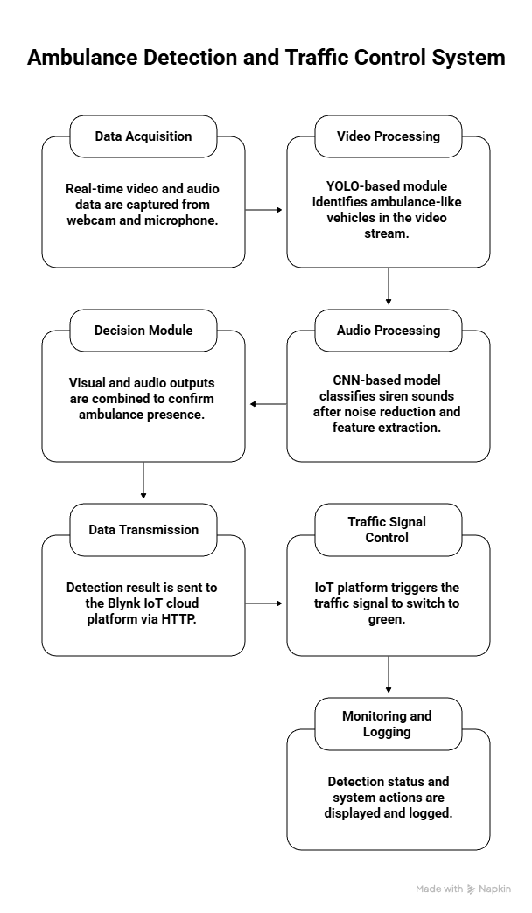

Modules:
- Video Acquisition Module
- Visual Ambulance Detection Module (YOLO)
- Image Processing and Feature Analysis Module
- Audio Acquisition Module
- Siren Detection Module (CNN-Based Sound Classification)
- Dual-Mode Decision Module (Audio + Visual Fusion)
- IoT Communication Module (Blynk Integration)
- Traffic Signal Control Module
- System Monitoring and Alert Module
- Data Logging and Performance Evaluation Module

1. Video Acquisition Module
This module is responsible for capturing live video streams from a camera installed at a traffic intersection. The webcam continuously records frames at a fixed resolution to ensure consistent input quality for further processing. Each frame is resized and preprocessed to meet the input requirements of the object detection model. This module acts as the primary visual data source and enables real-time monitoring of road conditions.

2. Visual Ambulance Detection Module (YOLO)
This module utilizes the YOLO (You Only Look Once) deep learning algorithm to perform real-time object detection on captured video frames. YOLO processes each frame in a single forward pass of a convolutional neural network, enabling fast and efficient detection. The model identifies vehicles such as trucks and buses and generates bounding boxes around them. This step narrows down potential ambulance candidates for further verification.

3. Image Processing and Feature Analysis Module
After vehicle detection, this module extracts the region of interest (ROI) corresponding to detected vehicles. The ROI is converted into the HSV color space to analyze distinctive color features commonly found in ambulances, such as red and white patterns. Binary masks are generated to detect these colors, and pixel intensity thresholds are applied to confirm ambulance characteristics. This module enhances visual detection accuracy by eliminating false positives caused by non-emergency vehicles.

4. Audio Acquisition Module
This module captures real-time audio signals using a microphone placed near the traffic intersection. Audio data is recorded at a predefined sampling rate and duration to ensure compatibility with the sound classification model. The continuous audio capture allows the system to detect emergency sirens even when visual conditions are poor, such as during nighttime or heavy traffic.

5. Siren Detection Module (CNN-Based Sound Classification)
This module performs intelligent sound analysis using deep learning techniques. The captured audio signal undergoes noise reduction to minimize background disturbances such as engine noise and horns. Mel-spectrogram features are extracted to represent frequency variations over time in a form suitable for CNN processing. A trained convolutional neural network then classifies the audio into categories such as ambulance siren, traffic noise, or other emergency sounds, providing confidence scores for each prediction.

6. Dual-Mode Decision Module (Audio–Visual Fusion)
This module integrates the outputs of both visual and audio detection modules to make a final decision. An ambulance is confirmed only when both visual identification and siren detection are positive. This fusion strategy significantly reduces false detections that may occur when using only a single modality. By combining two independent sources of information, the system achieves higher reliability and robustness in real-world environments.

7. IoT Communication Module (Blynk Integration)
This module handles communication between the detection system and the IoT cloud platform. Once an ambulance is confirmed, detection data is transmitted to the Blynk Cloud using secure HTTP API calls. The module ensures reliable data transfer, prevents duplicate alerts, and enables real-time monitoring through a mobile or web dashboard. This connectivity allows the system to interact with external hardware or control systems.

8. Traffic Signal Control Module
Based on the signal received from the IoT communication module, this module initiates traffic signal control actions. The traffic light is automatically switched to green to provide a clear corridor for the approaching ambulance. This module can be integrated with microcontrollers such as ESP32 to control physical traffic signals, enabling real-world deployment of the system.

9. System Monitoring and Alert Module
This module provides real-time visualization of system status, including detection results, confidence levels, and alert messages. Visual indicators are displayed on the monitoring interface to inform operators about ambulance detection and traffic signal status. This module enhances transparency and allows manual supervision if required.

10. Data Logging and Performance Evaluation Module
This module records detection events, timestamps, confidence values, and system responses for future analysis. Logged data is used to evaluate system performance, analyze detection accuracy, and identify areas for improvement. This module supports system validation and helps in fine-tuning models for enhanced reliability.

Methodology
The proposed AI-based ambulance detection and traffic signal control system follows a structured methodology that integrates computer vision, deep learning–based audio analysis, and IoT communication to ensure accurate and reliable emergency vehicle detection. The overall workflow of the system is described in the following steps.

Step 1: Data Acquisition
Real-time data is collected from two primary sources:
- Video data is captured using a webcam installed at a traffic intersection to monitor approaching vehicles.
- Audio data is recorded using a microphone to capture environmental sounds and emergency sirens.
These inputs form the foundation for visual and acoustic analysis.

Step 2: Video Preprocessing
The captured video frames are resized to a fixed resolution and converted into blob format to meet the input requirements of the YOLO object detection model. Preprocessing ensures uniformity and improves detection efficiency.

Step 3: Visual Vehicle Detection
The YOLO-based object detection model processes each video frame to identify vehicles such as trucks and buses. Bounding boxes are generated around detected vehicles, and confidence thresholds are applied to eliminate weak detections.

Step 4: Ambulance Visual Verification
From the detected vehicle regions, image processing techniques are applied to verify ambulance characteristics. The regions of interest are converted to HSV color space, and red and white color masks are applied. Vehicles exhibiting strong ambulance-like color patterns are marked as visually detected ambulances.

Step 5: Audio Preprocessing
Audio signals are recorded at a predefined sampling rate and duration. Noise reduction techniques are applied to minimize background disturbances such as traffic noise. The cleaned audio signal is then prepared for feature extraction.

Step 6: Feature Extraction from Audio
Mel-spectrogram features are extracted from the preprocessed audio signals. These features capture the time–frequency characteristics of ambulance sirens and serve as input to the deep learning sound classification model.

Step 7: Siren Classification Using CNN
A trained Convolutional Neural Network (CNN) analyzes the Mel-spectrogram features to classify audio into categories such as ambulance siren, traffic noise, or other emergency sounds. Classification confidence is computed to validate detection reliability.

Step 8: Dual-Mode Decision Fusion
The system combines the results of visual detection and audio classification. An ambulance is confirmed only when both detections are positive and confidence thresholds are satisfied. This fusion approach significantly reduces false positives.

Step 9: IoT Communication and Control
Upon successful ambulance confirmation, the system sends a control signal to the Blynk IoT cloud platform using HTTP-based APIs. This signal can be used to trigger traffic signal control mechanisms.

Step 10: Traffic Signal Activation
The traffic signal control system switches the traffic light to green, providing a clear path for the ambulance. The system maintains the signal state for a predefined duration to ensure safe passage.

Step 11: Monitoring and Logging
Detection results, confidence levels, and system actions are displayed on the monitoring interface and logged for performance evaluation and future optimization.

Conclusion
This project successfully demonstrates the design and implementation of an AI-based smart ambulance detection and traffic signal control system that addresses the critical problem of emergency vehicle delays in congested traffic environments. By integrating computer vision, deep learning–based sound analysis, and IoT technologies, the proposed system provides an efficient and reliable solution for real-time ambulance detection.
The use of a YOLO-based visual detection model enables fast and accurate identification of ambulance-like vehicles from live video feeds, while the CNN-based siren detection module enhances reliability by analyzing real-time audio signals. The adoption of a dual-mode decision fusion approach, which confirms ambulance presence only when both visual and acoustic detections are positive, significantly reduces false detections and improves system robustness.
Upon successful detection, the system effectively communicates with the Blynk IoT cloud platform to trigger traffic signal control actions, thereby creating a green corridor for ambulances. This automated response minimizes human intervention and contributes to reduced emergency response time, improved traffic management, and enhanced public safety.
The proposed system is cost-effective, scalable, and suitable for smart city applications, as it relies on commonly available hardware and cloud-based infrastructure. With further enhancements such as multi-intersection deployment, GPS integration, and real-time traffic optimization, the system has strong potential for large-scale real-world implementation.

